**Aim:** Pivoting using Excel

**IDE:** Microsoft Excel

**Questions:**

* First in Order Sheet of Dataset Insert Name of Customers ,Gender,city,country from Customer Id and from Customer Sheet.
* And In order dataset extract months and year from order date make different columns for that.

1. **What is the most common order quantity?**

* Insert Pivot Table for given Dataset
* Insert Quantity in Row Label and Count of Orders in Values Field.
* **Answer :-** Quantity – 6

Count of Orders - 24

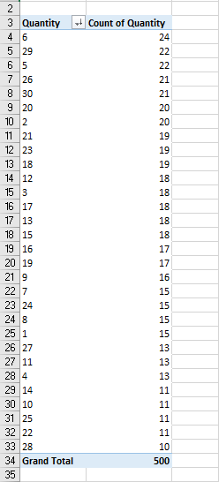

1. **Are there specific quarter with higher order volumes?**

* Insert Pivot Table for given Dataset.
* Insert Quarters in Row Labels and Insert Count of Quantities in Value Field
* **Answer :-** Quarters :- 3 and 4

Count of Quantity :- 136

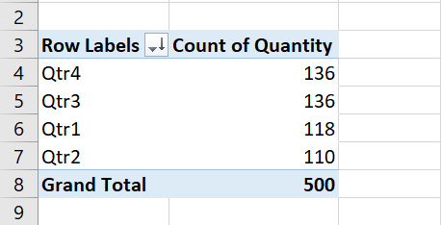

1. **How does order frequency vary over the month?**

* Insert Pivot Table for given Dataset.
* Insert the Months in Row Labels and Count of Orders in Values.
* **Answer :-** Month – 11 (November)

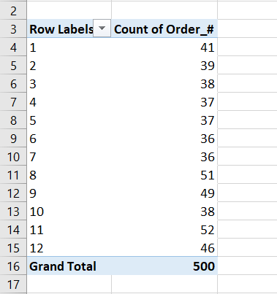 Count of Orders = 52

1. **Are there certain categories contributing more to revenue?**

* Insert the Pivot Table.
* Insert the Category_# in Row Labels and Sum of Total Cost in Value Field.
* 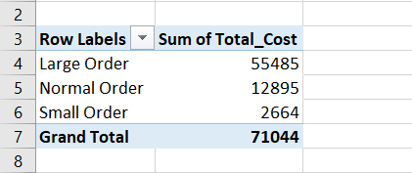**Answer :-**

1. **What is the distribution of orders across different order categories?**

* Insert the Pivot Table for given Dataset.
* Insert Order_Category_# in Row Label and Count of Order in Values

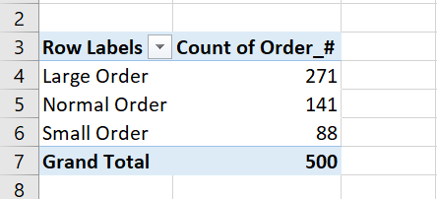

1. **Can you identify the most common product purchased in large orders?**

* Insert a Pivot Table for given Dataset.
* Place the Product_# in the Row Label and Count of Quantity in Values field.

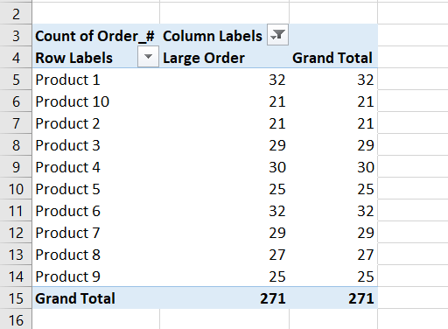

1. **What is the average quantity of products per order?**

* Insert a Pivot Table for given Dataset.
* And insert a Average Total_Cost in Values field.

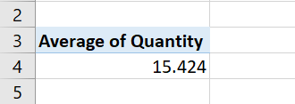

1. **Which product has the highest unit price?**

* Insert A Pivot Table for given dataset.
* Insert Product_# in Row Label and Max of Unit_Price in Values.

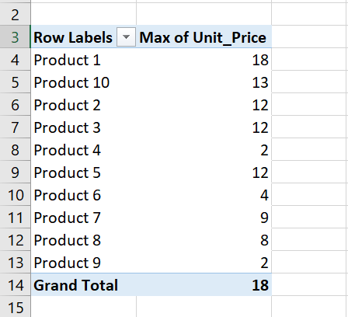

1. **What is the total revenue generated from large orders versus normal orders?**

* Insert A Pivot Table for given Dataset.
* Insert a Filtered Order_Category# as Large and Normal in Row Label and Insert Sum of Total_Cost in Values.

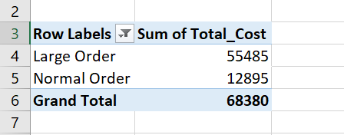

1. **What is the proportion of large orders to normal orders in the dataset?**

* Insert A Pivot Table for given Dataset.
* Insert The Filtered Orers_Category# as Large and normal and Insert Count of Orders_# as Values.

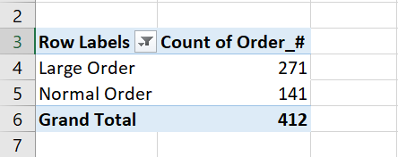

1. **How many unique customers are represented in the dataset?**

* Insert A Pivot Table for given Dataset.
* Insert a Name as Row Label and find the Count
* **Answer :-** 146

1. **What is the most frequently purchased product across all orders?**

* Insert A Pivot Table for given Dataset.
* Insert a Product_# as Row Label and Insert Count of Orders_# as Values.
* **Answer :-** Product – 3 with 60 Orders.

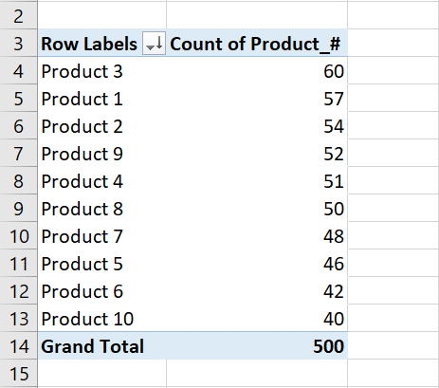

1. **What is the average total cost for each order category?**

* Insert A Pivot Table for given Dataset.
* Insert a Order_Category# in Row Label and Average of Total_Cost in Values.
* **Answer :-**

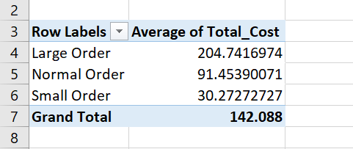

1. **How does the quantity of products impact the total cost in different order categories?**

* Insert A Pivot Table for given Dataset.
* Insert a Quantity in Row Label and Order_Category in Columns and Sum of Total_Cost as Values.
* **Answer :-**

1. **What is the proportion of small, normal, and large orders in the dataset?**

* Insert A Pivot Table for given Dataset.
* Insert a Order_Category in Row Label and Count of Order_Category# in Values.
* **Answer :-**

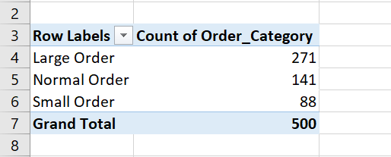

**Output:**

**Observation and Learnings:**

By Attempting this assignment we came to know the Various Functionalities of Microsoft Excel.